Low Level Design

Project Code | Group 4
Project Name | Online Banking System

Prepared / Modified by | Role | Date of preparation/ Modification
Upama Mondal ,  Sanjli Kumari | Designer | 18-SEP-2018
Reviewed by | Role | Date of review
Tanmaya K Acharya | Mentor
Approved by | Role | Date of Approval
Tanmaya K Acharya | Mentor
Circulation List | upama.mondal@capgemini.com,  bharath.nandibhatla@capgemini.com,  sanjli.kumari@capgemini.com,  naman.mehta@capgemini.com,  ayyagari.chandan@capgemini.com,  ashish.pathania@capgemini.com | Version Number : 1.0
Version number of the work product | Version 1.0

Table of Contents

1. Description Of The Unit 3
2. References 4
3. Dependencies / Assumptions 5
4. Class Diagrams 6
5. Sequence Diagrams 7
6. Design Components 8
6.1ListofComponents…….………………………………………….…………………………………8
6.2 List of Design Classes…………………………………………………………………………………….10

7. Reusable Routines/Components……………………………………………………. 11
8. Messages 12
9. Configuration Files 13
10. Crud Matrix Table 14
11. Data Mapping Matrix 15
12. Action Flow Matrix 16
13. Stored Procedures 17
14. Program Specification / Pseudo Code 18
REVISION HISTORY OF THE WORK PRODUCT 21
Description Of The Unit

The project is aimed to develop an Online Banking System for users to automate everyday tasks which has to be manually. This is a web based application that can be accessed over the web. This application can be used to add new bank users, view transactions, update personal details, raise service requests(here cheque book request). This system contains two user components, Admin component and User.

There are two different type of users to use this system. Each one of them would have some exclusive privileges (for e.g. User can transfer fund to some account but admin can add new user to the bank.)

- User should be able to
  - Login to the system using his/her credentials
  - View Mini/Detailed Statement
  - Change Address/Mobile No.
  - Raise Cheque Book Request
  - Track Service Request
  - Fund Transfer
  - Change Password
  - Logout

- Administrator should be able to

  - Login to the system using his/her credentials
  - Create new User
  - Logout

References

Reference | Description
Class Diagram | https://github.com/bnandibh/PLP_OnlineBankingSystem/blob/master/PLP%20Documents/ProjectDocuments/DesignDocuments/HLD/Class%20Diagram/ClassDiagram.jpg
URS | https://github.com/bnandibh/PLP_OnlineBankingSystem/blob/master/PLP%20Documents/ProjectDocuments/Requirements/CaseStudy/OnlineBankingSystem.doc
UTP | https://github.com/bnandibh/PLP_OnlineBankingSystem/blob/master/PLP%20Documents/Testing/UTP/Test_Case_OnlineBankingSystem_FundTransfer.xls
DB Design | https://github.com/bnandibh/PLP_OnlineBankingSystem/blob/master/PLP%20Documents/ProjectDocuments/DesignDocuments/HLD/DB%20Design/DB%20Design.xlsx

Dependencies / Assumptions
Dependencies:
Tables should be created accordingly in the database.

Assumptions:
The Admin details are stored in the database.
(Username:”admin” , Password:”root”)

.

Class Diagrams
Class Diagram
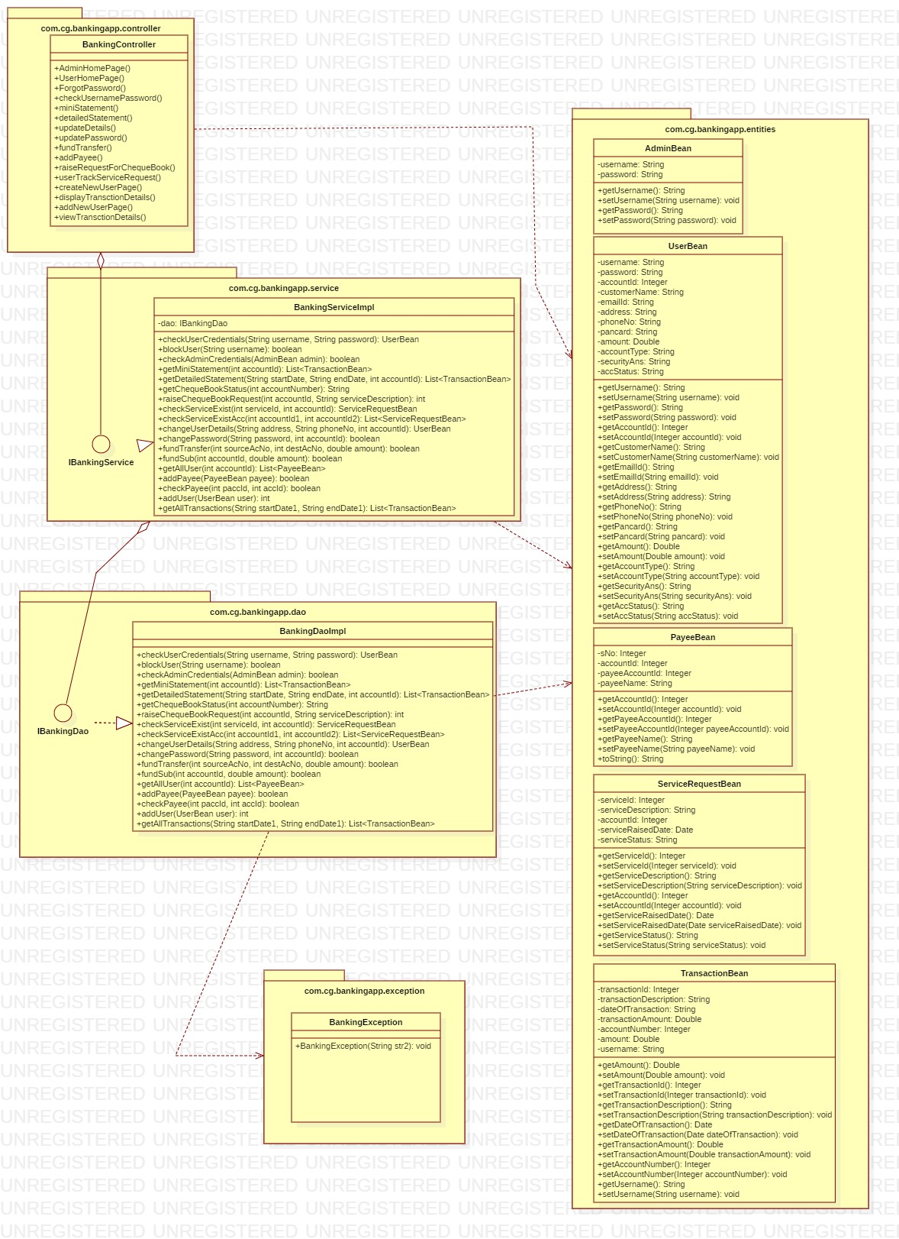

Sequence Diagrams

Sequence Diagram

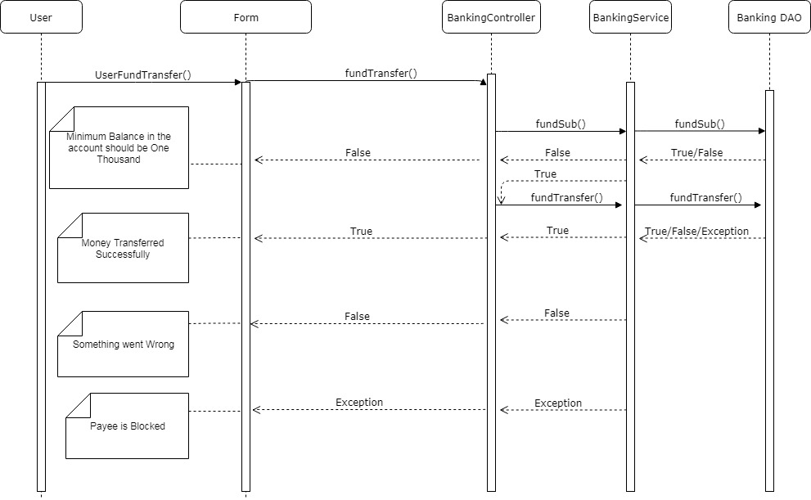

Design Components

List Of UI Components

Refer to ScreenShots folder

Sr. No. | LLD Name | Class Name | Method Name | Method Description
1 | FUND TRANSFER | PayeeBean | public PayeeBean() | Calls the constructor and creates an object of  PayeeBean.
2 | FUND TRANSFER | BankingController | public List<PayeeBean> getAllUser(int accountId) throws BankingException | Sets the model attribute.  Calls the service layer.
3 | FUND TRANSFER | BankingServiceImpl | public List<PayeeBean> getAllUser(int accountId) throws BankingException | Calls the DAO layer.
4 | FUND TRANSFER | BankingDaoImpl | public List<PayeeBean> getAllUser(int accountId) throws BankingException | Returns the result to BankingServiceImpl and then to the controller.
5 | FUND TRANSFER | BankingController | public boolean fundSub(int accountId, double amount) throws BankingException | Calls the service layer method
6 | FUND TRANSFER | BankingServiceImpl | public boolean fundSub(int accountId, double amount) throws BankingException | Calls the DAO layer.
7 | FUND TRANSFER | BankingDaoImpl | public boolean fundSub(int accountId, double amount) throws BankingException | Validates the amount to be transferred and returns to the service layer and then to the controller.
8 | FUND TRANSFER | BankingController | public boolean fundTransfer(int sourceAccountId,int destAccountId, double amount) throws BankingException | Calls the Service layer method.
9 | FUND TRANSFER | BankingServiceImpl | public boolean fundTransfer(int sourceAccountId,int destAccountId, double amount) | Calls the DAO layer method.
10 | FUND TRANSFER | BankingDaoImpl | public boolean fundTransfer(int sourceAccountId,int destAccountId, double amount) throws BankingException | Transfers the amount from the user account to the payee’s account and update the account balance of the both.

List Of Design Classes

Re-Usable Routines/Components
Re-Usable Routines/Components

- CSS files
- BankingException class

Messages

#. | Type | Message Text
M1 | Error(HTML) | Please fill out this field.
M2 | Error | Please select a payee!
M3 | Message | Payee added successfully!
M4 | Error | No User available with this Payee Account Id
M5 | Error | User cannot add himself as payee
M6 | Message | Money transferred successfully!
M7 | Error | Minimum balance in the account should be one thousand.
M8 | Error | Please enter a value greater than 0!
M9 | Error | The Payee account is blocked

Configuration Files

File Name | Path | Description
Log4j.properties | /OnlineBanking/src/main/resources/ | To configure log4j.
web.xml | /OnlineBanking/src/main/webapp/WEB-INF | To configure the web project.
servlet-config.xml | /OnlineBanking/src/main/webapp/WEB-INF/config | To get Application context container
jpaContext.xml | /OnlineBanking/src/main/resources/ | To get Bean factory container

Crud Matrix Table

# | Table Name | Create | Read | Update | Delete
1 | user_login | Y | Y | Y | N
2 | transaction | Y | Y | Y | N

Data Mapping Matrix

Sr. No. | Screen Label | Field Source | Field Type | Data Type | Length | Data Flow | Mandatory
1 | Select a Payee | PayeeBean | DropDown | NA | NA | UI | Yes
2 | Add a Payee | addPayee.obj | HyperLink | NA | NA | UI→UI | Yes
3 | Amount: | UserBean.amount | Number | Double | {1, } | UI | Yes
4 | Transfer | BankingController | Button | NA | NA | UI->C | Yes

Legend

UI (User Interface Only)
UI → C (User Interface to Controller)

Action Flow Matrix

Sr. No. | Action | Description | Process
1 | On click of Add Payee | Redirected addPayee page | The User clicks on Add Payee link on fund transfer page and gets redirected to addPayee page
2 | On click of Transfer button in fund transfer page | The fund gets transferred successfully under correct conditions from user account and credited to the payee’s account. | Amount is entered in the field by the User which gets transferred into the payee’s account when transfer button is pressed and amount in both account gets updated into the database.

Stored Procedures

# | Stored Procedure Name  (with Description) | Input/Out Parameters | Type | Size
1. | NA

Program Specification / Pseudo Code

Pseudo Code:
- Client Side Scripting:
None

- Server Side Scripting:
BEGIN
Call the Service Layer for transferring the fund.
END

Pseudo Code:
<ACTION: FUND_TRANSFER >

BEGIN
Call fundTransfer(@RequestParam int accountNo,
@RequestParam double amount) of Controller class
Presentation Layer.
BEGIN
Call getAllUser( int accountId ) of BankingServiceImpl in
Presentation Layer.
BEGIN
Call getAllUser( int accountId ) of BankinghDaoImpl in
Service Layer.
BEGIN
Create query to fetch the Array List of Payee
From Database in Data Access Layer.
Return Array List of Payee to Service Layer
END
Return Array List of Payee to Presentation Layer.
END

END

BEGIN
IF No Payee is selected or Transfer amount is Zero
IF amount !=0
Navigate to fundTransferPage jsp page and
Print Error Message “Please select a payee!”.
ELSE
Navigate to fundTransferPage jsp page and
Print Error Message “Amount should be greater than Zero”.
ELSE
IF Amount in the user Account is less than 1000
Navigate to fundTransferPage jsp page and
Print Error Message “Minimum balance in the account
should be One Thousand”.

ELSE Call fundTransfer( int sourceAcNo, int destAcNo,
double amount) of BankingServiceImpl in Presentation Layer.
BEGIN
Call fundTransfer( int sourceAcNo, int destAcNo,
double amount) of BankingDaoImpl in Service Layer.
BEGIN
IF destination account status is block
RAISE “block”
ELSE
Transfer amount from source to destination account
and add details in the Transaction Table.
Return true to Service Layer.
END
Return value received from Data Access Layer to
Presentation Layer.
END
IF returned value is true
Navigate to fundTransferPage jsp page and
Print Success Message “Money Transferred Successfully!”
ELSE IF return value is false
Navigate to fundTransferPage jsp page and
Print Error Message “Something Went Wrong.”
ELSE IF
EXCEPTION
When Banking Exception
IF Exception.getMessage() is “block”.
Navigate to fundTransferPage jsp page and
Print Error Message “The Payee Account is Block.”
ELSE
Navigate to fundTransferPage jsp page and
Print Error Message “Something Went Wrong.”

END
END

.

REVISION HISTORY OF THE WORK PRODUCT
<To be maintained by projects>

# | Date | Version # | Section Changed | Details of changes made | Approved By
1
2

